Incident Resulted In: ___ injury ___ illness __√_ property damage ____ near miss ____ first aid ___ medical aid ___ recurrence __ other

Location | Department
Location of Incident  (Be specific) | Date of incident  6th September 2022  Time am/pm  4:00 PM | Date reported accident/ incident  6th September 2022
  Main Campus- Pump Room

Injured Party NA
Name of Injured Person (if applicable) ____NA_________________________________________________

Home Address:_______________________________ Age: ____________ Sex: M / F

________________________________

Date of employment:__________________________ Occupation/Position: _________________________

Experience (time) in job:________________________
Incident Information NA
Supervisor:___________________ Date of first missed shift:_______________ No. of days lost__________

Approximate date of onset, if no specific date of injury:_________________________________________

Object/equipment/substance inflicting damage/injury:___________________________________________

Nature of injury:_____________________________ Body part(s) affected:_________________________

Witness Statement | Risk Assessment
Include and Attach on separate sheet  ( Security & Imdaad) | Attach any relevant risk assessment  Attached Risk Assessment & Method Statement
  Included and Attached on separate sheet

Description of events
Describe the sequence of events that lead to the incident
At around 03:51 pm, 6th September 2022, for old buildings in Main Campus, the active and newly installed fire protection pumps were Jockey Fire Pump and Electrical Fire Pump as new Diesel Fire Pump is currently under installation. There was no work activity in pump room and door was closed. There was water leakage occurred on the underground, main header sprinkler line pipe outside the R building. Both existing new fire pumps (jockey & electrical pump) run, accumulated smoke came out of the pump room and the source of smoke came from the Electrical Fire Pump.

Describe the sequence of events following the incident
1.Security Officer noticed excessive smoke coming out of the fire pump room and immediately notified the security supervisor at 3:51 pm to activate the fire emergency call.
2. Same time, Mr. Raj (Sr. Eng. Imdaad) during his site walk noticed the smoke from Fire pump room's door and immediately notified Imdaad's operations team and concern security officer at 3:53 p.m.
3. At 3:54 p.m., Mr. Raj also notified the incident to KU FMD representative. 4.Imdaad supervisor informed the emergency team members at simultaneously, at 3:54 p.m. 5.Imdaad's site Technician turns off the electrical pump (DB) inside the pump room at 3:54 p.m. 6.Imdaad's Technician and Security Officer used fire extinguisher ( CO2 & Powder ) at 3:54 p.m. 7. The Security supervisor called the civil defense and Imdaad help desk at 3:56 to inform about the incident. 8.Imdaad supervisory staff reported at the designated area @3.56 PM.
9.Imdaad safety officer reported the designated area at 3:59 p.m followed by SIBCA at 4:00 pm 10.At 4:10 p.m., the Firestone team arrived on site.
11. Civil defense arrived on site at 4:12 P.M. and conducted a detailed investigation.
12.Upon further site inspection, our team noticed that there was leakage from the Main header of Sprinkler line for R Building's, external area (Costa side).
13.The civil defense expert team or crime scene investigator arrived on site at 5.30 pm and conducted a detailed investigation.
14.Recommendation made to the fire stone team to conduct a thorough investigation and determine the source of the leak.
15. That same night, the Firestone team repaired the leak around 12:00Am.

Describe the task being performed at the time of the incident

There was no ongoing task being performed during the time of the incident, the pump room was in closed condition. However, new Fire Pumps, jockey pump and electric pump were recently installed as part of Sprinkler Projects.

Drawings / Photographs

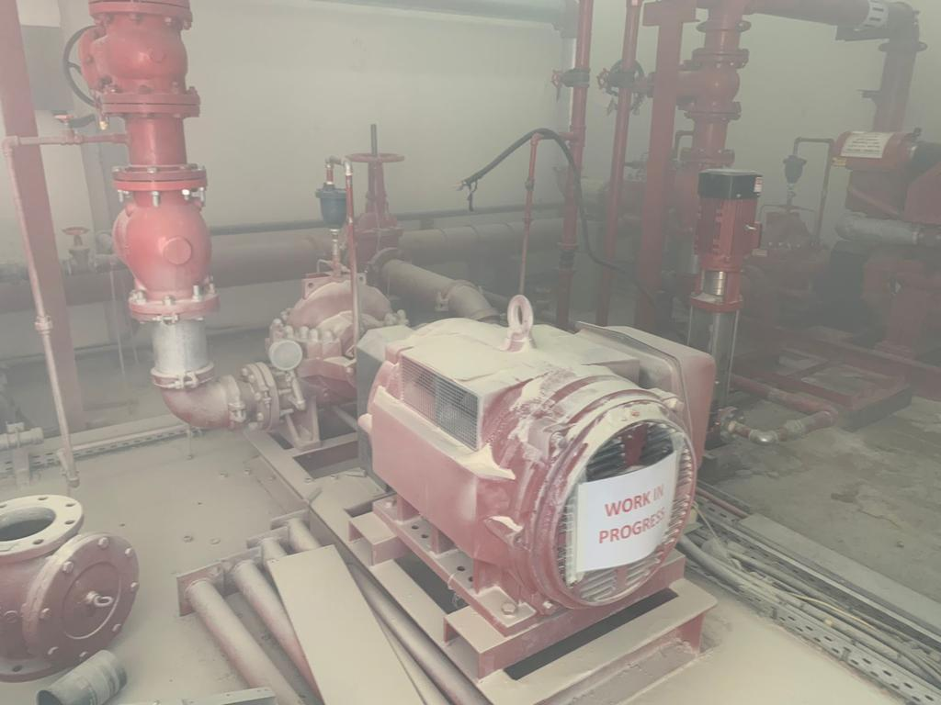 | 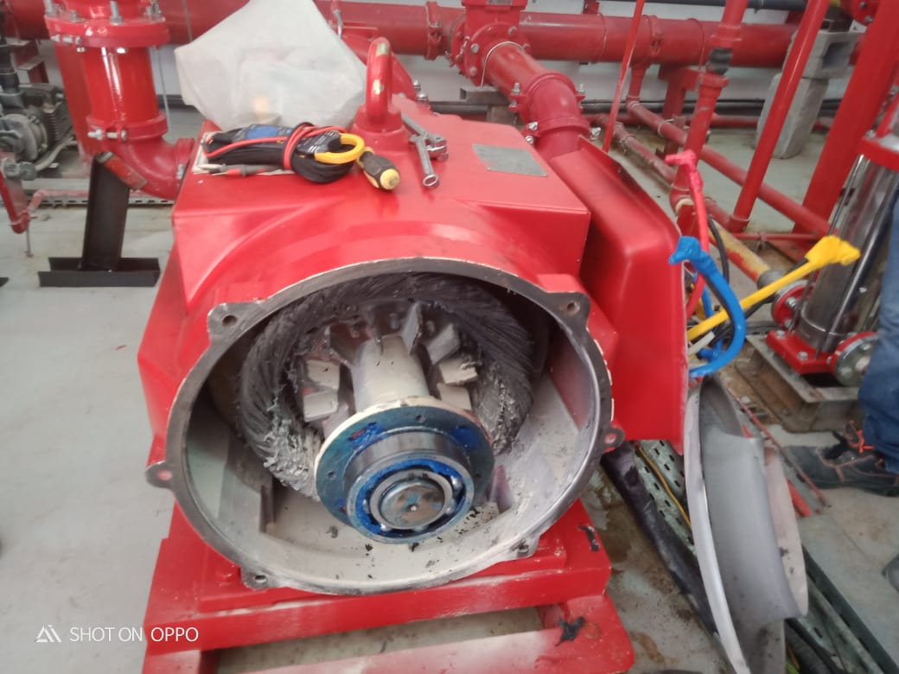 | 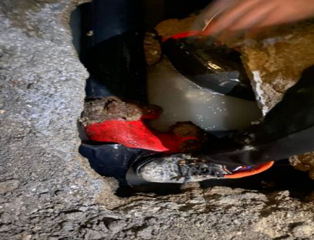
Attached Records:
-Method Statement
-Risk Assessment
-Observation Report/ Witness by Security
-MS Sprinkler System Installation
-Fire Stone Personnel & Competency
-Pump Manufacturing Test Report
- Pump Installation Check Sheet ( Fire Stone)

Risk Rating of Incident
Using the Two Variable Risk Matrix at right:  - Rate the consequences (severity) of the incident  - Rate the likelihood of the incident occurring or re-occurring  - Circle the resultant risk rating on the Risk Matrix
  Likelihood  Label | Consequences (Severity) Label
  Likelihood  Label | Negligible (1) | Significant (2) | Moderate (3) | Major (4) | Catastrophe (5)
  Almost Certain (A) | Medium | High | High | Very high | Very high
  Likely (B) | Medium | Medium | High | High | Very high
  Possible (C) | Low | Medium | High | High | High
  Unlikely (D) | Low | Low | Medium | Medium | High
  Rare (E) | Low | Low | Medium | Medium | High

Immediate causes: What substandard acts/practices and conditions caused or could cause the event? See Guideline
□ Failure to perform Pre Check-test & commissioning
□ Inadequate pump ventilation

Basic causes: What specific personal or job/system factors caused or could cause this event? See Guideline.
□Inadequate capability
- Lack of skill- QA/QC to perform pre-check as per Method Statement, not available on site
□Inadequate leadership/supervision
- Check/Pre-test & commissioning and installation test not available

Remedial actions: what has and/or should be done to control the causes listed?
□ Elimination Control □ Substitution Control □ Engineering Control □ Administrative Control □PPE

Prevention of Accident/Incident Recurrence
Describe what action is planned or has been taken to prevent a recurrence of the accident, based on the key contributing factors

Recommended Corrective Action | Action By Whom | Expected Completion Date | Action By Date
Pre-Check Test is to be Pre-recorded and confirm for each system installation prior to scheduling all Systems Testing and Commissioning. The Pre-Check test is to be witnessed by KU technical team (In-house FM, Fire Protection AMC, and KU representatives). This is to be applied to all fire pump installations and reinstallations. | Fire Stone | 8 September 2022 | 8 September 2022
Pre-Check, a checklist to include all the work environment aspects that may affect the normal operation of the fire protection pumps. | Fire Stone | 8 September 2022 | 8 September 2022
Fire Stone Project Manager to ensure to all manpower are onsite for the task required for the project.  - A competent person performs a pre-check test  - A competent tech’n to be available on-site 24/7 until the full system is fully operational | Fire Stone | 9 September 2022 | 9 September 2022

Persons Conducting Investigation
Name | Designation | Signature
Roberto Macahig | Lab Safety Specialist, EHS
Hend Al Zaabi | Lab Safety Specialist, EHS
Babu Anand | Hard Services Engineer, FM
 | Senior MEP Engineer
    Raj​
    Hussain

Send the initial investigation results (or a copy) to the EHS Manager within 72 hours. If the investigation is incomplete, it may be useful to nominate a person to be responsible for the completion of the investigation.

Incident Owner: Contact No.: Roberto Macahig

9 9 2022
Incident Report Due By: ____/____/____ Incident Received Back: ____/____/_____

Guideline

Immediate Causes
Substandard Acts/Actions  □Operating equipment without authority  □Failure to warn  □Failure to secure  □Operating at improper speed  □Making safety devices inoperable  □Removing safety devices  □Using defective equipment  □Failure to use PPE  □Improper loading  □Improper placement  □Improper lifting  □Improper position for task  □Servicing equipment in operation  □Horseplay  □Under influence of alcohol and/or other substances | Substandard Conditions  □Inadequate guards or barriers  □Inadequate or improper protective equipment  □Defective tools, equipment or materials  □Congestion or restricted action  □Inadequate warning system  □Fire and explosion hazard  □Poor housekeeping, disorder  □Hazardous environmental conditions, gases, smoke, dusts, fumes  □Noise exposure  □Radiation exposure  □High or low temperature exposure  □Inadequate or excess illumination  □Inadequate ventilation

Basic Causes
Personal Factors  □Inadequate capability  □Lack of knowledge/training  □Lack of skill  □Stress  □Improper motivation | Job Factors  □Inadequate leadership/supervision  □Inadequate engineering  □Inadequate purchasing  □Inadequate maintenance  □Inadequate tools/equipment  □Inadequate work standards  □Wear and Tear  □Abuse and/or misuse

